
75 Gardner Street; Hingham, MA 02043
781-875-1085; Fax: 781-875-1077; Cell: 781-264-7769; email: vpopp@vpoppinc.com
STRUCTURAL, DESIGN, FORENSICS & INSPECTIONS
Victor A. Popp, PE; MA License #41566
www.vpoppinc.com

A Primer on Residential Foundation Problems
© 2005 Victor A. Popp, PE

Note: the intention of this report is to provide and overview of foundation issues to consumers. Each situation can be different, and the layman is advised to use this report as background information only, while seeking the advice of experienced professionals. In most cases an on-site review and testing is needed to make truly informed engineering decisions on foundation problems.

Foundation Design:

Ideally, a properly designed and constructed residential foundation is designed to accommodate the weight of the structure, as well as the load bearing characteristics of the soils below. It should also be laid on undisturbed, native soil.

Continuous or “spread” footings should be cast along the base of walls when soils have low load bearing capacity. These work like “snowshoes” and spread the weight of the building out over a larger area of soil (see Figure #1 below). This can reduce soil stress to levels that are acceptable for the given soil, and thereby reduce chances of settlement.

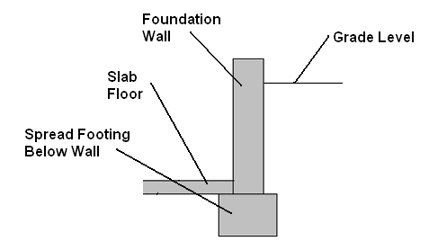

Figure #1: Cross Section of Foundation Wall Above Continuous Footing
Soil Mechanics (Geotechnical Engineering) is a complex science concerned with soil load bearing characteristics. Soils are characterized by the shape of the soil particles, and by the mixture of different sized particles in the soil. It can be difficult to explain this subject to the laymen, but the strength of soil has to do with how well the particles slide over each other..

In the ideal situation, the site soils will be “non-expansive” meaning they have little clays or silts (these are small sized particles with a tendency to expand and contract with moisture changes). As a general rule, sand has good load bearing capability; though moisture levels can also affect sand, and it is prone to short term settlement. Course grained sand is better than smooth, and a mixture of particle sizes is better than one size. Soils should always be free of organic material (“peat”). Usually soils contain a mixture of sand, silts, clays, and gravels. When all soil characteristics are considered during foundation design, the chances of damaging “settlement” are greatly reduced.

While soil load bearing characteristics can be determined by geotechnical testing, the Massachusetts Building Code (MA 780CMR) does not require such tests for residential, one and two family dwellings (due to the high cost). The Code instead dictates “minimum presumptive load bearing values” for different kinds of visible soil conditions. In general, the finer the soil, the lower the load bearing capacity, while having gravel (small stones) mixed in with the soil increases it. The Code soil classifications are adequate to prevent harmful settlement in most cases, provided the soil is “undisturbed” or left in its “native” stat (note: undisturbed soils are naturally compacted over thousands of years).

Moisture and ground water, also play a large role in the design of successful foundations, but foundations can be designed around poor soil conditions in almost all cases. In rare cases, it may seem prudent to build residences on “disturbed” soils and/or “fill,” but this is rare, and avoided. If it is necessary to build on these soils, foundations can be built on piles which extend down to good load bearing soils.

In colder climates, walls need to extend down below the frost line (4 feet in Massachusetts), while in warmer climates, foundations are nearer to the surface. This prevents freezing soils from effecting the building structure due to frost heaving which can lift or push horizontally on the foundation walls.

Concrete strength can be a factor in foundation problems. There are different types and strengths. Generally, 3000 psi concrete or higher is used. Water content in the mix, as well conditions during the curing process, can also affect the strength. Steel reinforcing (“re-bar”) can be added to improve strength, though this was not used much in older structures.

Note: Old “fieldstone” foundations and foundations made of concrete masonry units (CMU’s or “cinder blocks”) operate on similar principles. It should be noted that fieldstone foundations that are properly maintained have some advantages over poured concrete. These foundations often form horizontal cracks when they are used in foundations as basement walls. The force of the soil pushing against these walls can make them lean, and crack horizontally. The force can come from frost heaving (cold areas), or expansive soils. Expansive soils problems are reported to be rare in the Northeast. In general, an 8” thick CMU block wall should not hold back more than 4 feet of soil (“unbalanced fill” in basement situation).

Foundation Failure and Cracks:

While cracks in foundations are not unusual, not all houses have them. Cracks can be initiated by shrinkage of the concrete during the drying/curing process. These cracks are identifiable because they are generally thin (under 1/32 inch), uniform in width, vertical, and often spaced out at even intervals. Cracks can also result from premature backfilling, backfilling before the floor joists are installed, or by an inadvertent collision with construction equipment.

“Settlement” and “differential settlement” occur when a foundation is not designed or built correctly for the exact soil conditions below. The absence of footings is frequently the cause as well. These terms describe when soils below the foundation settle uniformly, or unevenly (respectively). Differential settlement means part of the foundation may settle in one direction, while adjoining parts do not. The result is cracks in the foundation walls, or loss of levelness. When cracks are large and accompanied by movement of walls, then the cause is generally differential settlement. Cracks often occur where the foundation walls change geometry (corners, window and door cutouts), but they can also occur along straight lengths of walls.

There are several different types of settlement. Some are short-term which occur early in the building’s life (caused by compaction of the soil under the weight of the new building); and longer term due to several factors (including “consolidation” as moisture levels are driven down under the structure by the weight of the structure and stress on the soil). Short term can last months. Long term can last for years, and even indefinitely.

In most cases settlement motions and damage decrease with time. Expansive soils which expand and contract as moisture levels go up and down can create problems as long as moisture levels change (for the life of the structure). In these situations, changes to areas around the foundation can affect the drainage and moisture levels (i.e., downspouts ending at the foundation, a plumbing leak under the house or other drainage changes can have detrimental effects). Proper drainage maintenance is important when expansive soils or frost heaving conditions exist.

Expansive soils can exert tremendous forces as they expand and press against foundation walls and even slab floors. “Heaving” of expansive soils in the presence of moisture can do extensive damage to slab floors. For the most part, these soils are not very prevalent in New England.

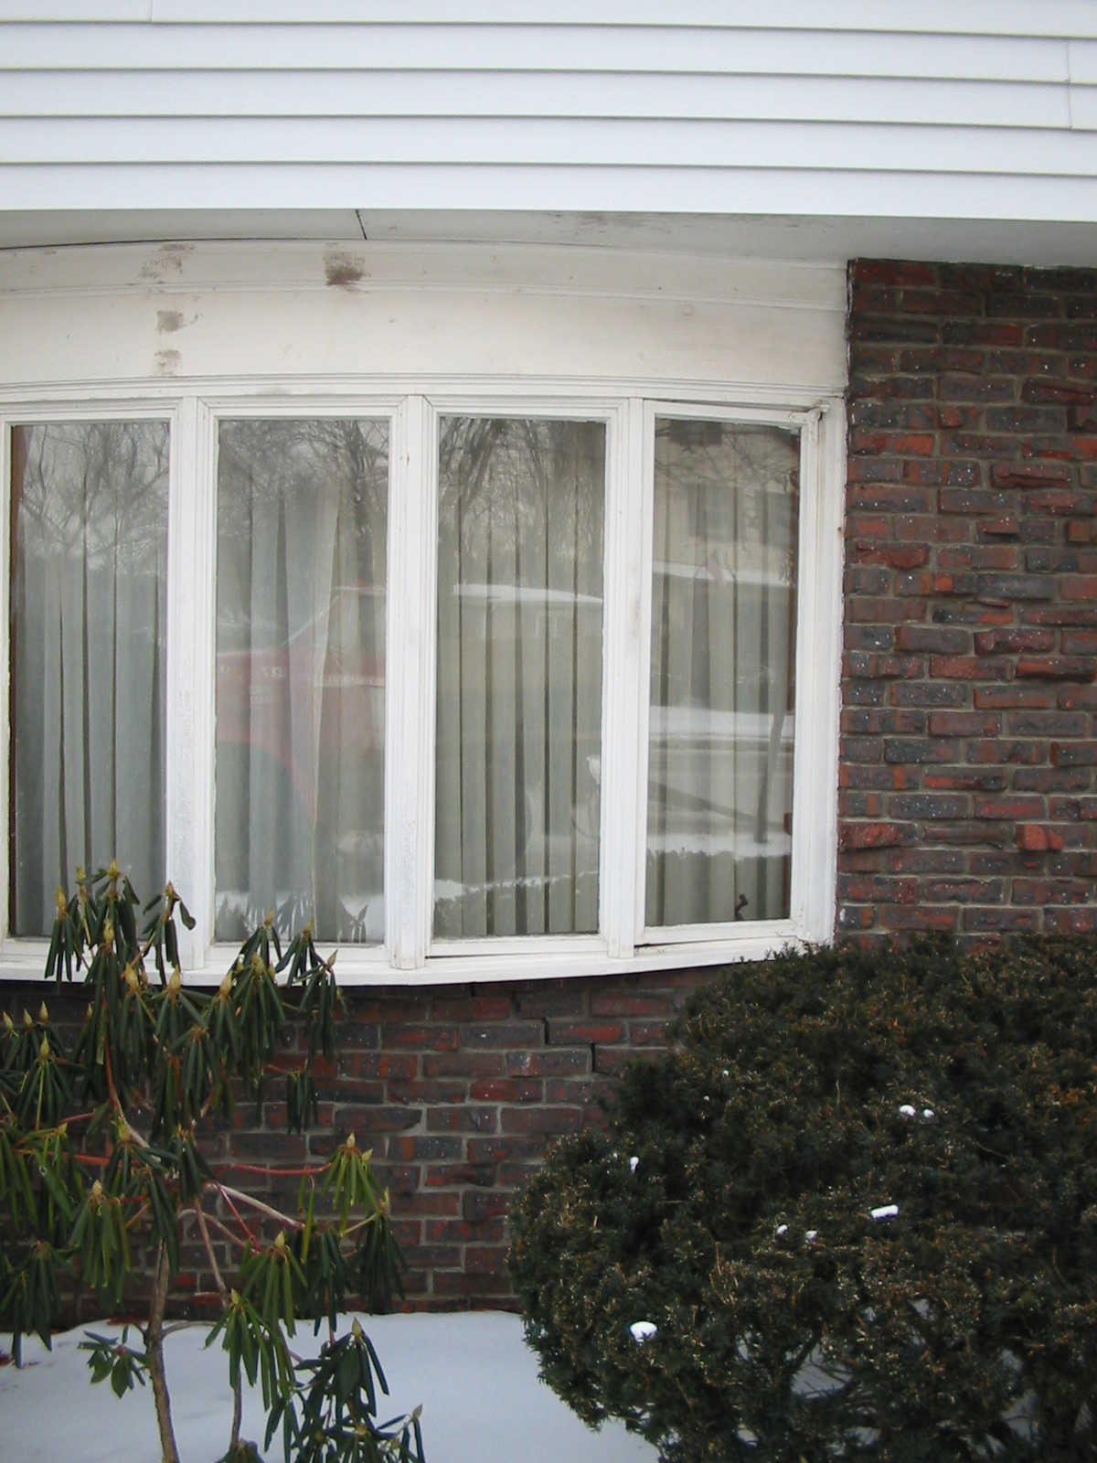

Figure 2: Structural Damage Caused by Foundation Failure.
Racked Bay Windows and Step Crack in Bricks (below second window from left).

Frost heave is a situation where water that is captured in the soil, freezes and expands. This can result in large horizontal forces pushing against the walls and/or vertical forces lifting slabs. These forces can easily crack concrete.

Thin cracks, less than 1/8 inch wide and uniform in width are generally caused by concrete shrinkage, and are considered cosmetic. They can run from the top to the bottom of the wall.

Many experts say that cracks wider than ¼ inch should be cause for concern; some call cracks greater than 3/8 inch to ½ inch “foundation failure.” Other experts say foundation failure only occurs when foundation cracks affect the structure above. This can be racked windows, cracked walls, and uneven floors. While these can lower the comfort factor for inhabitants, these problems in general do not mean the house is in danger of collapsing, but they are serious.

The biggest question should be: is the foundation still moving? In some cases, cracks were formed immediately after construction.(short term settlement). If this is the case, the crack can be epoxied to try to prevent moisture penetration and heat loss. Cracks can be monitored (width and position) by measuring and tracking the widths, photographing them, or patching them to see if they re-crack.
Any settlement should be noted, however, since it may mean the soil conditions are marginal. This would dictate that proper maintenance and changes to the structure should be considered . Monitoring cracks should be done as soon as possible, for peace of mind, and to get data for resale later.

Foundation Repair Decisions:

When a foundation wall moves or cracks the wooden frame above (which may be bolted to it) will try to move with the moving foundation sections, and can get damaged. This can result in the upper structure having bowed and cracked walls and floors; racked doors and windows; and even structural failure (where members begin to crack).

When foundation problems are present on an older existing house some consideration is needed. The effect on the structure, cost of repair, and cause of the problem is not usually clear. In addition, it must be determined whether the problems are old, current, and ongoing (will they get worse in the future?). Just because a house has “been here for a hundred years” does not guarantee the future structural integrity.

Generally problems should be addressed early, when they are minimal. An ounce of prevention is worth a pound of cure. With proper engineering review, the issues can be identified and monitored or rectified. They should not be ignored, however, because, even without catastrophic failure, problems can affect the inhabitability of the house and result in expensive repairs. In some cases inhabitability is a subjective issue (i.e., comfort level of residents, ongoing cosmetic issues); and in some cases it is not (i.e., issues that can result in damage to structure and require repair costs).

The rule of thumb for home inspectors is to recommend a structural engineer if foundation cracks are found in excess of ¼ inch, if wall sections show lateral movement or misalignment, if the cracks run in a horizontal direction, or if the cracks do not have uniform width.

Movements, misalignments, or settlements of approximately ½” are almost always a cause for concern. Yet each case is different.

Foundation Repair Work:

While there are foundation “repair” methods, most of these tend to be relatively costly, and in some cases unnecessary. It is often impossible to fix the problem without understanding the cause. If the repair is not done correctly, it can be ineffective. Proper engineering offers the best chance at a solution, though with all engineering there is some uncertainty, and often the solutions that offer the lowest risk to the homeowner, have the highest cost.

Problems with foundations should first be reviewed by a professional engineer. There is some overlap between engineering disciplines required to diagnose and fix foundation problems (civil, geotechnical, and structural). Depending on the obvious damage, issues with the upper structure issues (house, frame, or foundation) should first be addressed by an engineer versed in structural aspects of buildings. .

Most foundation “repair” techniques are aimed at “stabilizing” the foundation (i.e., preventing further movements), and not trying to put walls back to their original positions (i.e., close cracks and straighten walls back to original). If during the stabilization process the walls do get corrected, this is a side benefit.
The Decision Process:

Obviously it would be best if the house you own, or want to buy or sell did not have any foundation cracks. Some do not. But the question is: What do you do if you do have cracks? The decision can be difficult.

First, the advice of the proper professional should be sought. Poor drainage is a cause that can easily be remedied, and may be tried under a “wait and see approach” provided proper monitoring techniques are employed.

Other solutions will require a geotechnical study of the soils, and the results of that study could indicate that foundation repair is needed. Repair techniques can be relatively expensive, and are not covered in detail in this data sheet. Qualified geotechnical engineers and foundation repair professionals should be sought, and references checked.

Repair or stabilization methods are not covered in detail here, but can include chemical soil treatments, replacement, mud-jacking, digging out the foundation and adding underpinnings or piles. Helical piles can be driven deep into the soil. Combinations of these methods can also be used. In extreme cases, entire foundation replacements are done. In some cases drilling holes and adding rebar can help.

Small cracks can be filled with the newer method of injecting epoxy. This offers some structural resistance to future movement of walls, but is mostly used to prevent moisture from seeping through the crack.

Repairs to Structures on Newly Stabilized Foundations:

Once the foundation is stabilized, it may be necessary to repair or stabilize the structure above, if it had been damaged by foundation movements. Floors can often be jacked and re-shored. Often tapered wooden shims are used to lift floors up, and/or new floor supports added.

It is often not possible to return the building to “perfect” condition. Floors may never be exactly level again, but levelness can be improved. Racked doors and windows may have to be shimmed or re-hung. Trim and moldings may need to be repaired, cracks in walls filled, and re-painting may be needed. Sometimes it is enough to “take the curse” off of a house that has been damaged by settlement rather than try to return the residence to its original intended condition.

Costs, benefits, and risks must be considered and accepted by the homeowner throughout this process. Professionals can only advise homeowners on their options, as well as try to advise them on what the costs and risks are. In addition, it should be understood that not all engineering solutions are 100 % successful.

