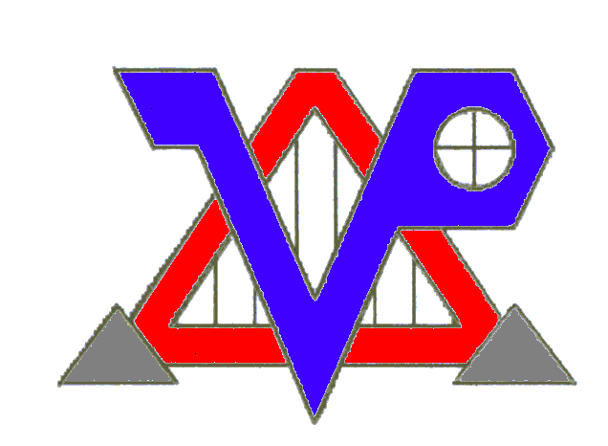
75 Gardner Street; Hingham, MA 02043
781-875-1085; Fax: 781-875-1077; Cell: 781-264-7769; email: vpopp@vpoppinc.com
STRUCTURAL, DESIGN, FORENSICS & INSPECTIONS
Victor A. Popp, PE; MA License #41566
www.vpoppinc.com

A Note on the Structural Effects of Insect Damage to Residential Structures

© 2004 Victor Popp, PE

The search for a house can impose a high financial and emotional cost. The confusion about the purchasing and inspection process can be frustrating as well. The last thing you want to hear at your home inspection is that “a pest control expert or structural engineer needs to be called in.” As is often the case, however, this is not as bad as it sounds.

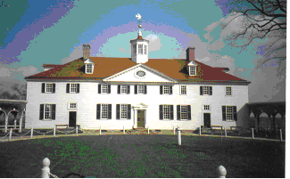

Mount Vernon: George Washington’s Home on the Potomac
Old wooden homes last hundreds of years, but there is often damage
and a cost for upkeep (photo by V.Popp, PE).

Role of the Inspectors:

Home inspectors, pest control experts, and structural engineers each require a separate license in Massachusetts. Home inspectors can look at many elements of your home, including looking for evidence of wood destroying insects. Generally this entails looking for holes in the wood, or “sawdust” in certain key areas of the building which are suspect. They may also poke around with a sharp tool or screw driver to find soft spots, and dig deeper to see if they are from insects. Home Inspectors will note any evidence of insect damage in their report, but beyond that there is not much else they can do. They will generally recommend that a pest control expert be called in to see if the colonies are still active, and if treatment is needed. Pest control experts have a separate license.

If the damage appears severe enough (it is often impossible to see the full extent of damage), then either the home or pest inspector may recommend a structural engineering review. Even if the pests are no longer active and damage to the timbers is old, the strength of the timbers could have been substantially compromised.

Role of the Engineer:

In most cases the repair of damaged buildings can be done by finding and replacing damaged members, one by one. In most cases, as long as the structure is not being changed, it does not even require a building permit. A structural engineer, on the other hand, looks at how all the parts of the house go together. They also keep an eye on balancing cost with risk. There are several reasons why it is a good idea to get an engineer involved:

- Replacing beams with damage indiscriminately can get expensive, and should not be done unnecessarily
- many houses were overbuilt, and can withstand some damage to members
- member damage is often partial, and replacement should be based on some level of damage
- since damage is often hidden behind walls, there are only two ways to proceed: one is to tear out walls, and another is to have an engineer look for other signs/clues that the structure is not compromised
- most homeowners will not allow too much poking and prodding, which could destroy the house (even if no damage is found).

A licensed engineer will most likely:

- Look at the damage to accessible members and calculate whether the reduction in cross section due to insect damage is enough to cause the structure to fail to meet Code.
- Review the damage with an eye to determining if the key structural elements are damaged, and check the effect of this damage on the overall structure.
- Attempt to work around the fact that many elements are not visible, and look for other signs of structural failure (i.e., cracks, settlement, bowing or sagging of adjoining walls, floors, and ceilings)

Most old houses and many new ones have insect damage. Depending on the extent of the damage, the wood often does not have to be totally replaced. The level of damage is often not easy to put in terms of black and white terms. While the easy answer for the structural repair contractor is to replace all damaged wood, it is also the most expensive answer! Reputable structural repair contractors try to avoid unnecessarily expensive, across the board wood replacements. This is why they recommend a structural engineering review.

What to Do After All the Opinions Are Given:

The home owner, pest inspector and structural engineer can advise the homeowner on the damage that they see, but cannot comment on the parts of the structure that they cannot see. They can advise the homeowner of their opinion of the structure, and their opinion of the likelihood that the structure is intact, based on their experience.

The biggest risk for the homeowner--and this risk ultimately must be borne by the homeowner---is what to do about the wood that cannot be seen. It is often behind finished walls. If all of the damage were visible, it would be easy to form an opinion on the integrity of the structure. All the experts can do, however, is due diligence in reviewing what they can see.

The homeowner cannot expect the inspectors and engineers to be miracle workers, but they can expect an opinion on the structure that is based on due diligence of the expert. If that is not enough, then a good “rule of thumb” is that: if you are uncomfortable with living in a house based on the opinion of three experts; and are concerned about the structural parts that could not be inspected; or cannot afford to do the repairs in a worst case scenario if the damage does turn out to be severe, then do not buy the house.

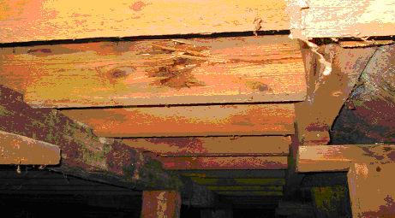

An Example of Hidden Damage:
Powder post beetle damage was uncovered in these “normal looking” joists.
After poking with a sharp tool, the full extent of damage was seen.
The remaining beam strength was roughly determined based on the remaining intact material.
Damage to the structure’s hidden beams was impossible to view, but by studying the surrounding
structural elements it was the engineer’s opinion
that there were no other significant hidden issues (photo by V.Popp, PE)

©2004 by V. Popp

Victor A. Popp, PE
Vice President
VPOPP Incorporated

